**Py MI Lab Schema Configuration Manager User Manual**

1. **Overview**

The Py MILab framework utilizes neutral JSON files between modules to allow users to analyze and upload data to their organization’s unique information management system. Because each organization will likely have a unique schema, unique data structures, etc., it is necessary to configure a given schema the neutral file outputs from Py MILab. To facilitate this process, the Py MILab Schema Configuration Manager was developed. The tool, built in Streamlit, an open-source Python framework that enables rapid building and deployment of web-based applications [1], allows users to upload their schema and configure individual attributes and associated meta-attributes to produce a configuration JSON file, which is then used by the Database Module in Py MILab to create new records and store test data.

Version 1.0 of the Py MILab Schema Configuration Manager currently supports configuration between Granta MI and Py MILab. Granta MI Enterprise is a material data management software system offered by Ansys that allows users to capture, manage, and share material information in an integrated relational database platform [2]. In Granta MI, individual schemas can be defined for a given table to allow unique data definition throughout the database, and information can be dynamically linked across tables to establish traceability amongst different aspects of the material lifecycle. Further details on Granta MI, linking behavior between tables, and the material lifecycle is given in the context of the NASA GRC ICME Schema in Ref. [3]. Future releases of the configuration tool will allow configuration to multiple tables and to other data management systems.

1. **Setup**

The Py MILab Configuration Manager is accessed at <https://schemaconfigurationgrc.streamlit.app/>. The home screen of the web application allows for users to upload two types of files (Figure 1):

1. Excel: The tool is expecting a Granta MI exported record via the MI: Viewer Application to determine the attributes in the user’s information management system.
2. JSON: The tool is expecting a JSON file *produced by the schema configuration tool*. This allows users to save their progress and return if necessary.

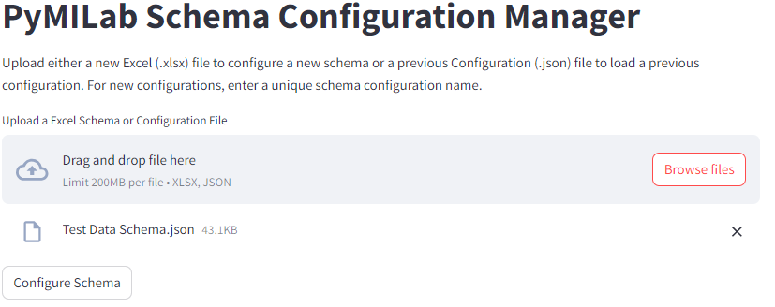

Figure 1. Py MILab Schema Configuration Manager Home Page

When either type of file is selected via the “Browse files” button, the uploaded file will display below the file selector and the “Configure Schema” button will appear. Selecting the “Configure Schema” button will read either file type and produce the schema configuration panel for the user.

* 1. **Creating the Excel Input File**

To initially configure a schema, the Python MILab Configuration Manager needs an excel file from the table that the neutral files will be configured to. To generate this excel file, users must export data from *any* record from the desired table in MI: Viewer. The file can be downloaded following the instructions outlined in Figure 2.

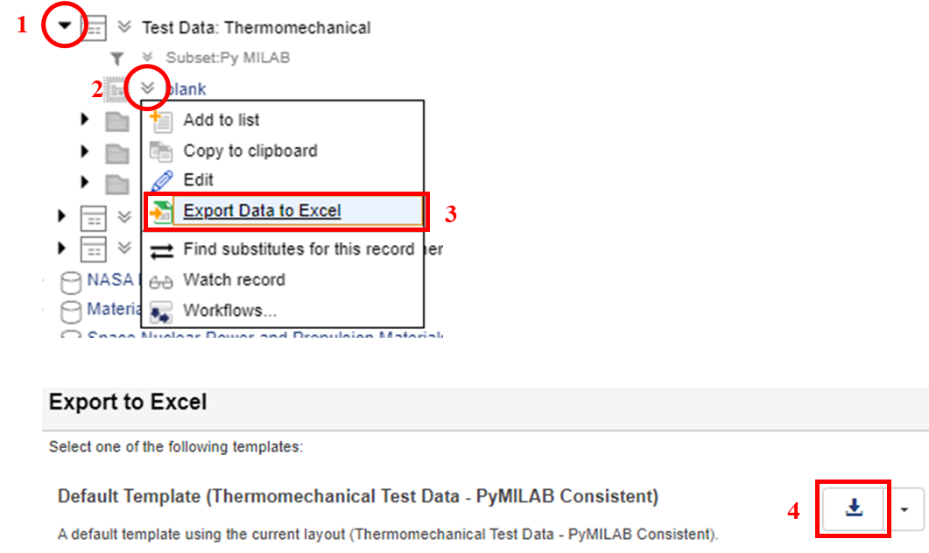

Figure 2. Generating the Excel Input File for the Py MILab Configuration Manager

1. **Schema Configuration**

The schema configuration panel currently supports three classes of attributes that can be configured to the neutral file attributes (Figure 3), each accessible selecting the “” next to each class:

1. Single Value Attributes
2. Functional Attributes
3. Tabular Attributes

A full list of the neutral file attributes in Py MILab, a description of the attribute, and the data type is given in Appendix A. The fourth expander allows for the user to determine the placement of the record (i.e., the folder structure) for the record within the configured table.

In Version 1.0 of the Py MILab Schema Configuration Manager, it is currently assumed that unit conversion for point attributes will be handled in the Py MILab Database module. Additionally, no configuration to each discrete text attribute’s list of options is performed. If an invalid value is given in the Py MILab neutral files, any non-compliant value will produce an error during the import process in the Database module that can be addressed by the user on a case-by-case basis. Future versions of the configuration tool will look to set desired units for point values and incorporate the discrete list options in the configuration manager to prevent any errors during the import process.

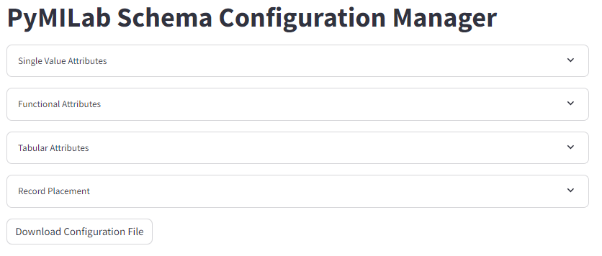

Figure 3. Schema Configuration Panel

* 1. **Single Value Attributes**

Single Value attributes are defined as any attribute where one to one pairing with the single value attributes in Py MILab neutral files is expected. In the context of Granta M, this includes point, range, discrete text, short text, long text, file, and hyperlink attributes (see Ref. [3] for a description of Granta MI attributes). When the Single Value Attributes container is expanded, the single value attribute names will be populated in the left-hand column and a select box to match a corresponding Py MILab Attribute will be populated in the right-hand column (Figure 4). The select box for each attribute pairing can be searched to reduce the full list of attributes in order to facilitate schema configuration.

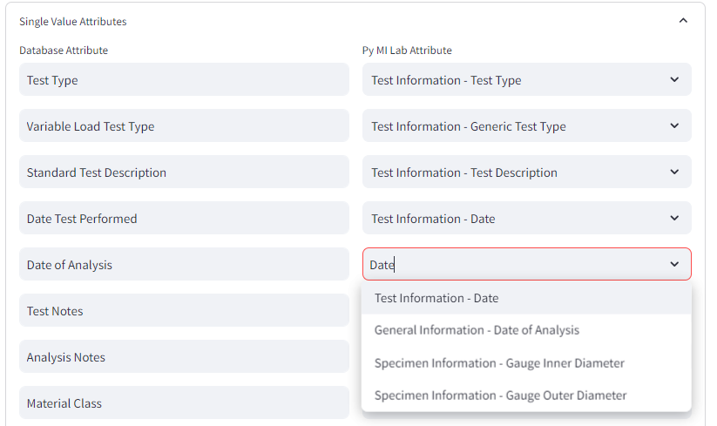

Figure 4. Schema Configuration Panel: Single Value Attributes

* 1. **Functional Attributes**

The Functional Attributes container allows configuration of the different array attributes in Py MILab to produce X-Y plots. When the Functional Attributes container is expanded, the functional attribute names will be populated in the left-hand column. Select boxes for the X-axis (i.e., the parameter) and Y-axis attributes are created in the center and right-hand columns, respectively, each containing a list of all point array Py MILab attributes (Figure 5). The select box for each attribute pairing can be searched to reduce the full list of attributes in order to facilitate schema configuration. Currently, only float functional attribute types are configurable.

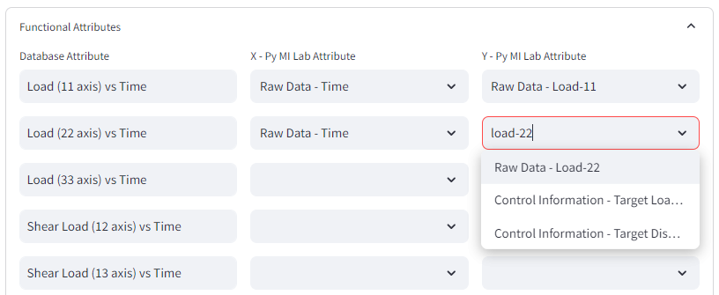

Figure 5. Schema Configuration Panel: Functional Attributes

* 1. **Tabular Attributes**

The Tabular Attributes container allows configuration of the different attributes in Py MILab to produce to each column in a tabular attribute within a user’s information management system. When the Tabular Attributes container is expanded, a select box containing all of the tabular attributes in the user’s schema is created (Figure 6a). Selecting an attribute will dynamically create two columns to configure the tabular attribute. The left-hand column will be populated with each column name in the selected tabular attribute, and the right-hand column will present select boxes containing all Py MILab attributes. The select box for each attribute pairing can be searched to reduce the full list of attributes in order to facilitate schema configuration. Both single value and array Py MILab attributes are available for configuration to enable dynamic linking to other tables in a user’s schema via a single value linking attribute (see Ref. [3] for additional details on tabular linking).

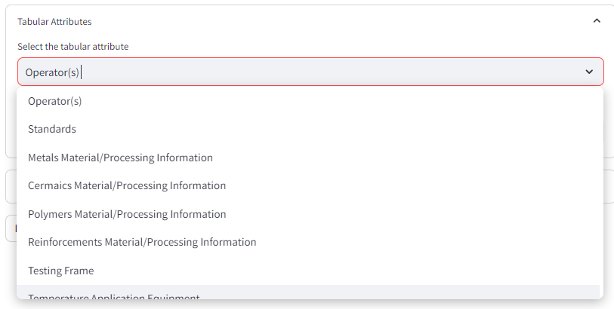

(a)

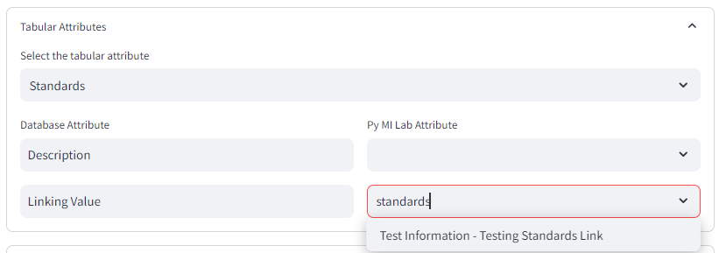

(b)

Figure 6. Schema Configuration Panel: Tabular Attributes. (a) Selecting the tabular attribute in the user’s information management system and (b) associating columns with Py MILab attributes

* 1. **Record Placement**

To determine the placement of each record given a set of pre-defined rules, the Record Placement container allows users to define the attributes that control the placement of records and the format of each folder name (Figure 7). In the Record Placement container, an initial entry box is presented to the user to define the number of folder levels (i.e., top level folder and subfolders). For each level selected, an entry box for the number of conditions, a multiselect box containing all single value Py MILab attributes to determine the naming attribute(s), and an entry box for the formatting of the folder name is presented (see Levels 1-4 in Figure 7).

The multiselect box option allows multiple attributes to be checked for values to determine the correct folder name. For example, if the folder name is dependent on the constant strain applied in a relaxation test (see Level 5 in Figure 7), three possible attributes could be populated dependent on the material orientation relative to the test direction (i.e., Relaxation Hold Strain-11, Relaxation Hold Strain-22, or Relaxation Hold Strain-33 could be populated). When determining the record name using this record placement configuration, the Database module will check all three Py MILab attributes for populated values and select the attribute that contains a value. If multiple attributes are defined and populated, it will default to choosing the last first selected and populated.

The format entry box defaults to a value of “[attribute]”, indicating that the folder name will exactly match the attribute value. If additional text is desired, it can be added before or after the “[attribute] entry. For example, in Level 4 of Figure 7, if the Test Information – Test Temperature attribute value was 800, the folder name would be “800 °C”.

If multiple conditions are needed, changing the Conditions entry box to a value greater than 1 generates three additional columns that the user can edit. The first (left-most) allows the user to select a conditional attribute, the second allows the user to select either “ $=$” or “ $≠$” , and the third allows the user to select the conditional value. When the Database module is determining the folder name, it will first check each of the conditional attributes for a populated value. If the conditional attribute values meet the conditional values in the third column, the corresponding naming attribute and format will be used.

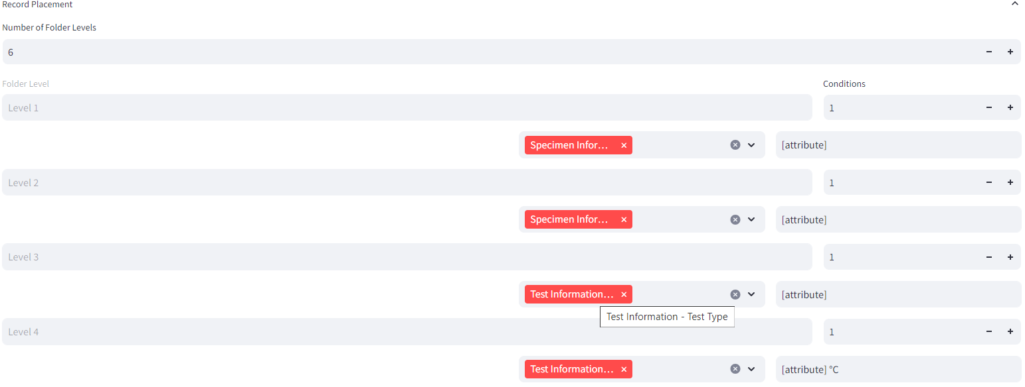

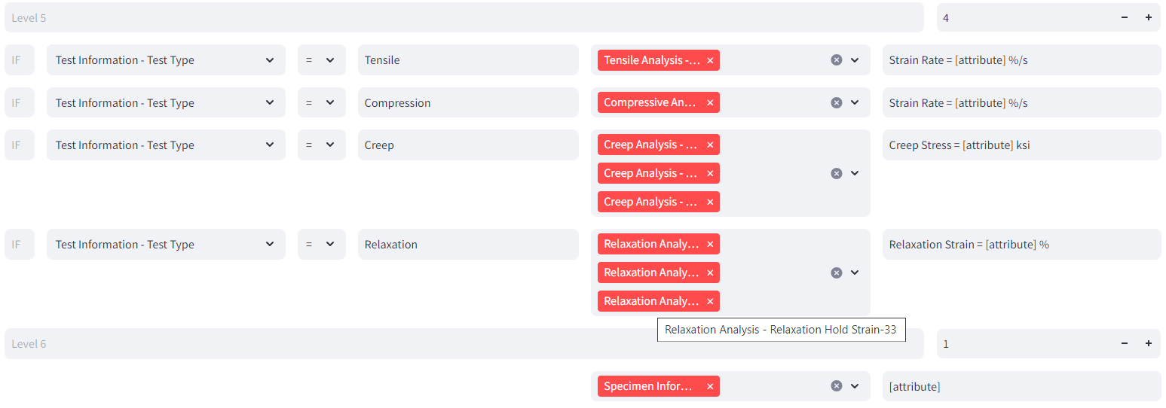

Figure 7. Schema Configuration Panel: Record Placement

Table 1. Example (Abbreviated) Py MILab Populated Fields

|  |  |
| --- | --- |
| **Py MILab Attribute** | **Attribute Value** |
| Specimen Information – Material Class | Titanium Alloy |
| Specimen Information – Material Name | Ti-6Al-4V |
| Test Information – Test Type | Relaxation |
| Test Information – Test Temperature | 800 |
| Tensile Analysis – Strain Rate | 1e-5 |
| Compressive Analysis – Compressive Strain Rate |  |
| Relaxation Analysis – Relaxation Hold Strain-11 | 1.2 |
| Relaxation Analysis – Relaxation Hold Strain-22 |  |
| Relaxation Analysis – Relaxation Hold Strain-33 |  |
| Creep Analysis – Creep Hold Stress-11 |  |
| Creep Analysis – Creep Hold Stress-11 |  |
| Creep Analysis – Creep Hold Stress-11 |  |
| Specimen Information – Specimen Name | TestSpecimen_01 |

To demonstrate the record placement, consider an abbreviated Py MILab data record shown in Table 1. When using the record placement rules identified in Figure 7, the resultant record placement in the user’s database would be:

Free Folder SVG, PNG Icon, Symbol. Download Image. Titanium Alloy

Free Folder SVG, PNG Icon, Symbol. Download Image. Ti-6Al-4V

Free Folder SVG, PNG Icon, Symbol. Download Image. Relaxation

Free Folder SVG, PNG Icon, Symbol. Download Image. 800°C

Free Folder SVG, PNG Icon, Symbol. Download Image. Relaxation Strain = 1.2%

Record Vector Icons free download in SVG, PNG Format TestSpecimen_01

1. **Saving/Loading Schema Configurations**

To save any current progress made or create a finalized configuration file, selecting the “Download Configuration File” button (see Figure 3) will automatically generate a JSON file. The created JSON file can be re-uploaded via the file selector when the tool is reloaded (see Figure 1) to edit an existing configuration, and is also supplied to the Py MILab Database module to automatically populate and create records within a user’s information management system.

**Appendix A: Py MILab Neutral File Attribute Information**

Py MILab contains two neutral files: one that contains information regarding the raw data collection populated by the Raw Data Module in Py MILab, denoted herein as the “Raw Data Neutral File”, and one that contains the subsequent analysis performed by the Analysis Module in Py MILab, dented herein as the “Analysis Neutral File”. Each neutral file uses a nested JSON structure, containing sub-categories at the first level and individual attributes at the second level. Each attribute is defined as either a point value, string value, point array, string array, or Boolean. Additionally, attributes may be defined as a dictionary (denoted herein as “dict”), which will contain its own set of attributes that matches one of the aforementioned attribute types.

# Raw Data Neutral File

The Raw Data Neutral File contains four sub-categories:

1. Raw Data – stores all raw data arrays from the test machine and measurement devices and the associated units for each array.
2. Control Information – stores the control or turn points entered by the user to define the various stages of the test.
3. Specimen Information – stores all information regarding the material and specimen pedigree, including material name and pedigree links, specimen geometry, post-processing, etc.
4. Test Information – stores all information regarding the conduction and measurement of the test, including test machine and measurement device information, test environment, operators, and test funding information.

A.1.1 Raw Data

Table 2. Raw Data – Raw Data Attributes

|  |  |  |
| --- | --- | --- |
| Name | Value Type | Description |
| Time | point array | Time data points |
| Displacement-11 | point array | Displacement data points along the 11-axis |
| Displacement-22 | point array | Displacement data points along the 22-axis |
| Displacement-33 | point array | Displacement data points along the 33-axis |
| Deformation-12 | point array | Displacement data points along the 12-axis |
| Deformation-13 | point array | Displacement data points along the 13-axis |
| Deformation-23 | point array | Displacement data points along the 23-axis |
| Load-11 | point array | Load data points along the 11-axis |
| Load-22 | point array | Load data points along the 22-axis |
| Load-33 | point array | Load data points along the 33-axis |
| Load-12 | point array | Load data points along the 12-axis |
| Load-13 | point array | Load data points along the 13-axis |
| Load-23 | point array | Load data points along the 23-axis |
| Strain-11 | point array | Strain data points along the 11-axis |
| Strain-22 | point array | Strain data points along the 22-axis |
| Strain-33 | point array | Strain data points along the 33-axis |
| Strain-12 | point array | Strain data points along the 12-axis |
| Strain-13 | point array | Strain data points along the 13-axis |
| Strain-23 | point array | Strain data points along the 23-axis |
| Stress-11 | point array | Stress data points along the 11-axis |
| Stress-22 | point array | Stress data points along the 22-axis |
| Stress-33 | point array | Stress data points along the 33-axis |
| Stress-12 | point array | Stress data points along the 12-axis |
| Stress-13 | point array | Strain data points along the 13-axis |
| Stress-23 | point array | Stress data points along the 23-axis |
| Temperature | point array | Temperature data points |
| Index | point array | Index values (i.e., the index or count of each data point) |
| Units | dict (see Table 3) | Dictionary containing associated units for raw data |

Table 3. Raw Data – Raw Data – Units Attributes

|  |  |  |
| --- | --- | --- |
| Name | Value Type | Description |
| Time | string | Units of the time values |
| Displacement | string | Units of the displacement values |
| Load | string | Units of the load values |
| Strain | string | Units of the strain values |
| Stress | string | Units of the stress values |
| Temperature | string | Units of the temperature values |

A.1.2 Control Information

Table 4. Raw Data – Control Information Attributes

|  |  |  |
| --- | --- | --- |
| Name | Value Type | Description |
| Stage Name | string array | List of stage names |
| Target Time | point array | Target end time for each stage |
| Target Displacement-11 | point array | Target end displacement in the 11-direction for each stage |
| Target Displacement-22 | point array | Target end displacement in the 22-direction for each stage |
| Target Displacement-33 | point array | Target end displacement in the 33-direction for each stage |
| Target Deformation-12 | point array | Target end displacement in the 12-direction for each stage |
| Target Deformation-13 | point array | Target end displacement in the 13-direction for each stage |
| Target Deformation-23 | point array | Target end displacement in the 23-direction for each stage |
| Target Load-11 | point array | Target end load in the 11-direction for each stage |
| Target Load-22 | point array | Target end load in the 22-direction for each stage |
| Target Load-33 | point array | Target end load in the 33-direction for each stage |
| Target Load-12 | point array | Target end load in the 12-direction for each stage |
| Target Load-13 | point array | Target end load in the 13-direction for each stage |
| Target Load-23 | point array | Target end load in the 23-direction for each stage |
| Target Strain-11 | point array | Target end strain in the 11-direction for each stage |
| Target Strain-22 | point array | Target end strain in the 22-direction for each stage |
| Target Strain-33 | point array | Target end strain in the 33-direction for each stage |
| Target Strain-12 | point array | Target end strain in the 12-direction for each stage |
| Target Strain-13 | point array | Target end strain in the 13-direction for each stage |
| Target Strain-23 | point array | Target end strain in the 23-direction for each stage |
| Target Stress-11 | point array | Target end stress in the 11-direction for each stage |
| Target Stress-22 | point array | Target end stress in the 22-direction for each stage |
| Target Stress-33 | point array | Target end stress in the 33-direction for each stage |
| Target Stress-12 | point array | Target end stress in the 12-direction for each stage |
| Target Stress-13 | point array | Target end stress in the 13-direction for each stage |
| Target Stress-23 | point array | Target end stress in the 23-direction for each stage |
| Target Temperature | point array | Target end temperature for each stage |
| Control Mode | string array | Control mode for the stage (Displacement, Load, Strain, Stress, or Temperature) |
| Defined | Boolean | True/False logic of whether the stages are defined or not |

A.1.3 Specimen Information

Table 5. Raw Data – Specimen Information Attributes

|  |  |  |
| --- | --- | --- |
| Name | Value Type | Description |
| Material Name | string | The name of the material |
| Material Class | string | The characterization of the material (e.g., Metal, Polymer, Ceramic, etc.) |
| Pedigree Link | string | The linking value to the pedigree table |
| Specimen Link | string | The linking value to the specimen table |
| Specimen Name | string | The name of the individual specimen |
| Cross-Sectional Shape | string | The shape of the gauge cross-section |
| Gauge Area | point | The gauge area of the specimen |
| Gauge Length | point | The gauge length of the specimen |
| Gauge Width | point | The gauge width of the specimen |
| Gauge Thickness | point | The gauge thickness of the specimen |
| Gauge Outer Diameter | point | The gauge outer diameter of the specimen |
| Gauge Inner Diameter | point | The gauge inner diameter of the specimen |
| Specimen Orientation | string | The orientation of the specimen relative to the test direction |
| Surface Finish | string | The surface finish applied to the specimen prior to testing |
| Machining Method | string | The machining method used for the specimen |
| Units | dict  (see Table 6) | Dictionary containing associated units for specimen information |

Table 6. Raw Data – Specimen Information – Units Attributes

|  |  |  |
| --- | --- | --- |
| Name | Value Type | Description |
| Area | string | Units of the area values |
| Length | string | Units of the length values |
| Thickness | string | Units of the thickness values |

A.1.4 Test Information

Table 7. Raw Data – Test Information Attributes

|  |  |  |
| --- | --- | --- |
| Name | Value Type | Description |
| Date | string | The date the test was performed |
| Operator | string | The test operator |
| Test Type | string | The type of test conducted |
| Generic Test Type | string | The type of variable test conducted if the test type is "Generic" |
| Test Description | string | A description of the test performed |
| Test Temperature | point | The test temperature |
| Test Humidity | point | The test humidity |
| Test Environment | string | The test environment |
| Test Frame Link | string array | Linking value(s) for any test frames used |
| Heating Method | string array | The heating method(s) used for non-ambient tests |
| Heating Equipment Link | string array | Linking value(s) for any equipment used for heating |
| Heating Equipment Notes | string array | Associated notes for the heating equipment used |
| Load Measurement Method | string array | The load measurement method(s) used |
| Load Equipment Link | string array | Linking value(s) for any equipment used for loading |
| Load Measurement Notes | string array | Associated notes for the loading equipment used |
| Strain Measurement Method | string array | The strain measurement method(s) used |
| Strain Measurement Link | string array | Linking value(s) for any equipment used for measuring strain |
| Strain Measurement Notes | string array | Associated notes for the strain measurement equipment used |
| Temperautre Measurement Method | string array | The temperature measurement method(s) used |
| Temperature Measurement Link | string array | Linking value(s) for any equipment used for measuring temperature |
| Temperature Measurement Notes | string array | Associated notes for the temperature measurement equipment used |
| Testing Standards Link | string array | List of linking values for any standards used |
| Project Information Link | string | Linking value to the project information |
| Test Notes | string | Any additional notes on the conduction of the test |

# Analysis Neutral File

The Analysis Neutral File contains four sub-categories:

1. General Information – stores all information regarding analysis that applies to all test types.
2. Tensile Analysis – stores all analysis information for a test where the first stage is tensile loading. If the second stage is tensile unloading, the analysis is also stored here.
3. Compressive Analysis – stores all analysis information for a test where the first stage is compressive loading. If the second stage is compressive unloading, the analysis is also stored here.
4. Shear Analysis – stores all analysis information for a test where the first stage is shear loading. If the second stage is shear unloading, the analysis is also stored here.
5. Relaxation Analysis – stores all analysis information for any test where the second stage is relaxation.
6. Creep Analysis – stores all analysis information for any test where the second stage is creep.
7. Stages – stores all information defining and analyzing each individual stage for an arbitrary number of load stages.

A.2.1 General Information

Table 8. Analysis – General Information Attributes

|  |  |  |
| --- | --- | --- |
| Name | Value Type | Description |
| Date of Analysis | string | Date the analysis was performed |
| Point of Contact | string | Point of Contact for the analysis |
| Units | dict (see Table 9) | Associated units for the analyzed data |
| Analysis Notes | string | Any additional notes on the test analysis |

Table 9. Analysis – General Information – Units Attributes

|  |  |  |
| --- | --- | --- |
| Name | Value Type | Description |
| Time | string | Units for all time data |
| Displacement | string | Units for all displacement data |
| Load | string | Units for all load data |
| Strain | string | Units for all strain data |
| Stress | string | Units for all stress data |
| Temperature | string | Units for all temperature data |

A.2.2 Tensile Analysis

Table 10. Analysis – Tensile Analysis Attributes

|  |  |  |
| --- | --- | --- |
| Name | Value Type | Description |
| Modulus-11 | point | Elastic modulus in the 11-direction |
| Modulus-22 | point | Elastic modulus in the 22-direction |
| Modulus-33 | point | Elastic modulus in the 33-direction |
| Poissons Ratio-12 | point | Poisson’s Ratio in the 12-plane |
| Poissons Ratio-13 | point | Poisson’s Ratio in the 13-plane |
| Poissons Ratio-23 | point | Poisson’s Ratio in the 23-plane |
| Poissons Ratio-21 | point | Poisson’s Ratio in the 21-plane |
| Poissons Ratio-31 | point | Poisson’s Ratio in the 31-plane |
| Poissons Ratio-32 | point | Poisson’s Ratio in the 32-plane |
| Proportional Limit-11 | point | Proportional limit in the 11-direction |
| Proportional Limit-22 | point | Proportional limit in the 22-direction |
| Proportional Limit-33 | point | Proportional limit in the 33-direction |
| Proportional Limit Strain-11 | point | Strain at proportional limit in the 11-direction |
| Proportional Limit Strain-22 | point | Strain at proportional limit in the 22-direction |
| Proportional Limit Strain-33 | point | Strain at proportional limit in the 33-direction |
| Yield-11 | dict (see Table 11) | List of yield stress values in the 11-direction at a given offset strain |
| Yield-22 | dict (see Table 11) | List of yield stress values in the 22-direction at a given offset strain |
| Yield-33 | dict (see Table 11) | List of yield stress values in the 33-direction at a given offset strain |
| Ultimate Strength-11 | point | Ultimate strength in the 11-direction |
| Ultimate Strength-22 | point | Ultimate strength in the 22-direction |
| Ultimate Strength-33 | point | Ultimate strength in the 33-direction |
| Strain at UTS-11 | point | Strain at ultimate strength in the 11-direction |
| Strain at UTS-22 | point | Strain at ultimate strength in the 22-direction |
| Strain at UTS-33 | point | Strain at ultimate strength in the 33-direction |
| Failure Strength-11 | point | Failure strength in the 11-direction |
| Failure Strength-22 | point | Failure strength in the 22-direction |
| Failure Strength-33 | point | Failure strength in the 33-directionn |
| Strain at Failure-11 | point | Strain at failure strength in the 11-direction |
| Strain at Failure-22 | point | Strain at failure strength in the 22-direction |
| Strain at Failure-33 | point | Strain at failure strength in the 33-direction |
| Strain Rate | point | Strain rate for the tensile loading segment |
| Stress Rate | point | Stress rate for the tensile loading segment |
| Unloading Modulus-11 | point | Unloading modulus in the 11-direction |
| Unloading Modulus-22 | point | Unloading modulus in the 22-direction |
| Unloading Modulus-33 | point | Unloading modulus in the 33-direction |
| Reversible Strain-11 | point | Reversible strain after unloading in the 11-direction |
| Reversible Strain-22 | point | Reversible strain after unloading in the 22-direction |
| Reversible Strain-33 | point | Reversible strain after unloading in the 33-direction |
| Irreversible Strain-11 | point | Irreversible strain after unloading in the 11-direction |
| Irreversible Strain-22 | point | Irreversible strain after unloading in the 22-direction |
| Irreversible Strain-33 | point | Irreversible strain after unloading in the 33-direction |

Table 11. Analysis – Custom Yield Attributes

|  |  |  |
| --- | --- | --- |
| Name | Value Type | Description |
| Offset Strain | point array | Offset strain(s) for yield stress analysis |
| Yield Strength | point array | Associated yield stress(es) analysis |

A.2.3 Compressive Analysis

Table 12. Analysis – Compressive Analysis Attributes

|  |  |  |
| --- | --- | --- |
| Name | Value Type | Description |
| Compressive Modulus-11 | point | Compressive elastic modulus in the 11-direction |
| Compressive Modulus-22 | point | Compressive elastic modulus in the 22-direction |
| Compressive Modulus-33 | point | Compressive elastic modulus in the 33-direction |
| Compressive Poissons Ratio-12 | point | Compressive Poisson’s Ratio in the 12-plane |
| Compressive Poissons Ratio-13 | point | Compressive Poisson’s Ratio in the 13-plane |
| Compressive Poissons Ratio-23 | point | Compressive Poisson’s Ratio in the 23-plane |
| Compressive Poissons Ratio-21 | point | Compressive Poisson’s Ratio in the 21-plane |
| Compressive Poissons Ratio-31 | point | Compressive Poisson’s Ratio in the 31-plane |
| Compressive Poissons Ratio-32 | point | Compressive Poisson’s Ratio in the 32-plane |
| Compressive Proportional Limit-11 | point | Compressive proportional limit in the 11-direction |
| Compressive Proportional Limit-22 | point | Compressive proportional limit in the 22-direction |
| Compressive Proportional Limit-33 | point | Compressive proportional limit in the 33-direction |
| Compressive Proportional Limit Strain-11 | point | Compressive strain at proportional limit in the 11-direction |
| Compressive Proportional Limit Strain-22 | point | Compressive strain at proportional limit in the 22-direction |
| Compressive Proportional Limit Strain-33 | point | Compressive strain at proportional limit in the 33-direction |
| Compressive Yield-11 | dict (see Table 11) | List of compressive yield stress values in the 11-direction at a given offset strain |
| Compressive Yield-22 | dict (see Table 11) | List of compressive yield stress values in the 22-direction at a given offset strain |
| Compressive Yield-33 | dict (see Table 11) | List of compressive yield stress values in the 33-direction at a given offset strain |
| Compressive Ultimate Strength-11 | point | Compressive ultimate strength in the 11-direction |
| Compressive Ultimate Strength-22 | point | Compressive ultimate strength in the 22-direction |
| Compressive Ultimate Strength-33 | point | Compressive ultimate strength in the 33-direction |
| Compressive Strain at UTS-11 | point | Compressive strain at ultimate strength in the 11-direction |
| Compressive Strain at UTS-22 | point | Compressive strain at ultimate strength in the 22-direction |
| Compressive Strain at UTS-33 | point | Compressive strain at ultimate strength in the 33-direction |
| Compressive Failure Strength-11 | point | Compressive failure strength in the 11-directionn |
| Compressive Failure Strength-22 | point | Compressive failure strength in the 22-directionn |
| Compressive Failure Strength-33 | point | Compressive failure strength in the 33-directionn |
| Compressive Strain at Failure-11 | point | Compressive strain at failure strength in the 11-directionn |
| Compressive Strain at Failure-22 | point | Compressive strain at failure strength in the 22-directionn |
| Compressive Strain at Failure-33 | point | Compressive strain at failure strength in the 33-directionn |
| Compressive Strain Rate | point | Compressive strain rate for the tensile loading segment |
| Compressive Stress Rate | point | Compressive stress rate for the tensile loading segment |
| Compressive Unloading Modulus-11 | point | Compressive unloading modulus in the 11-direction |
| Compressive Unloading Modulus-22 | point | Compressive unloading modulus in the 22-direction |
| Compressive Unloading Modulus-33 | point | Compressive unloading modulus in the 33-direction |
| Compressive Reversible Strain-11 | point | Compressive reversible strain in the 11-direction |
| Compressive Reversible Strain-22 | point | Compressive reversible strain in the 22-direction |
| Compressive Reversible Strain-33 | point | Compressive reversible strain in the 33-direction |
| Compressive Irreversible Strain-11 | point | Compressive irreversible strain in the 11-direction |
| Compressive Irreversible Strain-22 | point | Compressive irreversible strain in the 22-direction |
| Compressive Irreversible Strain-33 | point | Compressive irreversible strain in the 33-direction |

A.2.4 Shear Analysis

Table 13. Analysis – Shear Analysis Attributes

|  |  |  |
| --- | --- | --- |
| Name | Value Type | Description |
| Shear Modulus-12 | point | Shear elastic modulus in the 12-direction |
| Shear Modulus-13 | point | Shear elastic modulus in the 13-direction |
| Shear Modulus-23 | point | Shear elastic modulus in the 23-direction |
| Shear Proportional Limit-12 | point | Shear proportional limit in the 12-direction |
| Shear Proportional Limit-13 | point | Shear proportional limit in the 13-direction |
| Shear Proportional Limit-23 | point | Shear proportional limit in the 23-direction |
| Shear Proportional Limit Strain-12 | point | Shear strain at proportional limit in the 12-direction |
| Shear Proportional Limit Strain-13 | point | Shear strain at proportional limit in the 13-direction |
| Shear Proportional Limit Strain-23 | point | Shear strain at proportional limit in the 23-direction |
| Shear Yield-12 | dict (see Table 11) | List of shear yield stress values in the 12-direction at a given offset strain |
| Shear Yield-13 | dict (see Table 11) | List of shear yield stress values in the 13-direction at a given offset strain |
| Shear Yield-23 | dict (see Table 11) | List of shear yield stress values in the 12-direction at a given offset strain |
| Shear Ultimate Strength-12 | point | Shear ultimate strength in the 12-direction |
| Shear Ultimate Strength-13 | point | Shear ultimate strength in the 13-direction |
| Shear Ultimate Strength-23 | point | Shear ultimate strength in the 23-direction |
| Shear Strain at UTS-12 | point | Shear strain at ultimate strength in the 12-direction |
| Shear Strain at UTS-13 | point | Shear strain at ultimate strength in the 13-direction |
| Shear Strain at UTS-23 | point | Shear strain at ultimate strength in the 123-direction |
| Shear Failure Strength-12 | point | Shear failure strength in the 12-direction |
| Shear Failure Strength-13 | point | Shear failure strength in the 13-direction |
| Shear Failure Strength-23 | point | Shear failure strength in the 23-direction |
| Shear Strain at Failure-12 | point | Shear strain at failure in the 12-direction |
| Shear Strain at Failure-13 | point | Shear strain at failure in the 13-direction |
| Shear Strain at Failure-23 | point | Shear strain at failure in the 23-direction |
| Shear Strain Rate | point | Compressive strain rate for the tensile loading segment |
| Shear Stress Rate | point | Compressive stress rate for the tensile loading segment |
| Shear Unloading Modulus-12 | point | Shear unloading modulus in the 12-direction |
| Shear Unloading Modulus-13 | point | Shear unloading modulus in the 13-direction |
| Shear Unloading Modulus-23 | point | Shear unloading modulus in the 23-direction |
| Shear Reversible Strain-12 | point | Shear reversible strain in the 12-direction |
| Shear Reversible Strain-13 | point | Shear reversible strain in the 13-direction |
| Shear Reversible Strain-23 | point | Shear reversible strain in the 23-direction |
| Shear Irreversible Strain-12 | point | Shear irreversible strain in the 12-direction |
| Shear Irreversible Strain-13 | point | Shear irreversible strain in the 13-direction |
| Shear Irreversible Strain-23 | point | Shear reversible strain in the 23-direction |

A.2.5 Relaxation Analysis

Table 14. Analysis – Relaxation Analysis Attributes

|  |  |  |
| --- | --- | --- |
| Name | Value Type | Description |
| Relaxation Hold Strain-11 | point | Constant applied strain in the 11-direction |
| Relaxation Hold Strain-22 | point | Constant applied strain in the 22-direction |
| Relaxation Hold Strain-33 | point | Constant applied strain in the 33-direction |
| Relaxation Total Time | point | Amount of time the constant strain is applied |
| Relaxation Stress Drop-11 | point | Change in stress during the relaxation in the 11-direction |
| Relaxation Stress Drop-22 | point | Change in stress during the relaxation in the 22-direction |
| Relaxation Stress Drop-33 | point | Change in stress during the relaxation in the 33-direction |
| Relaxation Reversible Strain-11 | point | Reversible strain after relaxation in the 11-direction |
| Relaxation Reversible Strain-22 | point | Reversible strain after relaxation in the 22-direction |
| Relaxation Reversible Strain-33 | point | Reversible strain after relaxation in the 33-direction |
| Relaxation Irreversible Strain-11 | point | Irreversible strain after relaxation in the 11-direction |
| Relaxation Irreversible Strain-22 | point | Irreversible strain after relaxation in the 22-direction |
| Relaxation Irreversible Strain-33 | point | Irreversible strain after relaxation in the 33-direction |
| Relaxation Time | point array | Time data points during the stress relaxation stage |
| Relaxation Strain-11 | point array | Strain data points in the 11-direction during the stress relaxation stage |
| Relaxation Strain-22 | point array | Strain data points in the 33-direction during the stress relaxation stage |
| Relaxation Strain-33 | point array | Strain data points in the 33-direction during the stress relaxation stage |
| Relaxation Stress-11 | point array | Stress data points in the 11-direction during the stress relaxation stage |
| Relaxation Stress-22 | point array | Stress data points in the 22-direction during the stress relaxation stage |
| Relaxation Stress-33 | point array | Strain data points in the 33-direction during the stress relaxation stage |
| Compressive Relaxation Hold Strain-11 | point | Constant applied compressive strain in the 11-direction |
| Compressive Relaxation Hold Strain-22 | point | Constant applied compressive strain in the 22-direction |
| Compressive Relaxation Hold Strain-33 | point | Constant applied compressive strain in the 33-direction |
| Compressive Relaxation Total Time | point | Amount of time the constant compressive strain is applied |
| Compressive Relaxation Stress Drop-11 | point | Change in compressive stress during the relaxation in the 11-direction |
| Compressive Relaxation Stress Drop-22 | point | Change in compressive stress during the relaxation in the 22-direction |
| Compressive Relaxation Stress Drop-33 | point | Change in compressive stress during the relaxation in the 33-direction |
| Compressive Relaxation Reversible Strain-11 | point | Compressive reversible strain after relaxation in the 11-direction |
| Compressive Relaxation Reversible Strain-22 | point | Compressive reversible strain after relaxation in the 22-direction |
| Compressive Relaxation Reversible Strain-33 | point | Compressive reversible strain after relaxation in the 33-direction |
| Compressive Relaxation Irreversible Strain-11 | point | Compressive irreversible strain after relaxation in the 11-direction |
| Compressive Relaxation Irreversible Strain-22 | point | Compressive irreversible strain after relaxation in the 22-direction |
| Compressive Relaxation Irreversible Strain-33 | point | Compressive irreversible strain after relaxation in the 33-direction |
| Compressive Relaxation Time | point array | Time data points during the compressive stress relaxation stage |
| Compressive Relaxation Strain-11 | point array | Compressive strain data points in the 11-direction during the stress relaxation stage |
| Compressive Relaxation Strain-22 | point array | Compressive strain data points in the 22-direction during the stress relaxation stage |
| Compressive Relaxation Strain-33 | point array | Compressive strain data points in the 33-direction during the stress relaxation stage |
| Compressive Relaxation Stress-11 | point array | Compressive stress data points in the 11-direction during the stress relaxation stage |
| Compressive Relaxation Stress-22 | point array | Compressive stress data points in the 22-direction during the stress relaxation stage |
| Compressive Relaxation Stress-33 | point array | Compressive stress data points in the 33-direction during the stress relaxation stage |
| Shear Relaxation Hold Strain-12 | point | Constant applied shear strain in the 12-direction |
| Shear Relaxation Hold Strain-13 | point | Constant applied shear strain in the 13-direction |
| Shear Relaxation Hold Strain-23 | point | Constant applied shear strain in the 23-direction |
| Shear Relaxation Total Time | point | Amount of time the constant shear strain is applied |
| Shear Relaxation Stress Drop-12 | point | Change in shear stress during the relaxation in the 12-direction |
| Shear Relaxation Stress Drop-13 | point | Change in shear stress during the relaxation in the 13-direction |
| Shear Relaxation Stress Drop-23 | point | Change in shear stress during the relaxation in the 23-direction |
| Shear Relaxation Reversible Strain-12 | point | Shear reversible strain after relaxation in the 12-direction |
| Shear Relaxation Reversible Strain-13 | point | Shear reversible strain after relaxation in the 13-direction |
| Shear Relaxation Reversible Strain-23 | point | Shear reversible strain after relaxation in the 23-direction |
| Shear Relaxation Irreversible Strain-12 | point | Shear irreversible strain after relaxation in the 12-direction |
| Shear Relaxation Irreversible Strain-13 | point | Shear irreversible strain after relaxation in the 13-direction |
| Shear Relaxation Irreversible Strain-23 | point | Shear irreversible strain after relaxation in the 23-direction |
| Shear Relaxation Time | point array | Time data points during the shear stress relaxation stage |
| Shear Relaxation Strain-12 | point array | Shear strain data points in the 12-direction during the stress relaxation stage |
| Shear Relaxation Strain-13 | point array | Shear strain data points in the 13-direction during the stress relaxation stage |
| Shear Relaxation Strain-23 | point array | Shear strain data points in the 23-direction during the stress relaxation stage |
| Shear Relaxation Stress-12 | point array | Shear stress data points in the 12-direction during the stress relaxation stage |
| Shear Relaxation Stress-13 | point array | Shear stress data points in the 13-direction during the stress relaxation stage |
| Shear Relaxation Stress-23 | point array | Shear stress data points in the 23-direction during the stress relaxation stage |

A.2.6 Creep Analysis

Table 15. Analysis – Creep Analysis Attributes

|  |  |  |
| --- | --- | --- |
| Name | Value Type | Description |
| Creep Hold Stress-11 | point | Constant applied stress in the 11-direction |
| Creep Hold Stress-22 | point | Constant applied stress in the 22-direction |
| Creep Hold Stress-33 | point | Constant applied stress in the 33-direction |
| Creep Total Time | point | Amount of time the constant stress is applied |
| Creep Time | point array | Time data points during the creep stage |
| Creep Strain-11 | point array | Strain data points in the 11-direction during the creep stage |
| Creep Strain-22 | point array | Strain data points in the 22-direction during the creep stage |
| Creep Strain-33 | point array | Strain data points in the 33-direction during the creep stage |
| Creep Stress-11 | point array | Stress data points in the 11-direction during the creep stage |
| Creep Stress-22 | point array | Stress data points in the 22-direction during the creep stage |
| Creep Stress-33 | point array | Stress data points in the 33-direction during the creep stage |
| Creep Strain Rate-11 | point array | Strain data points in the 11-direction during the creep stage |
| Creep Strain Rate-22 | point array | Strain data points in the 22-direction during the creep stage |
| Creep Strain Rate-33 | point array | Strain data points in the 33-direction during the creep stage |
| Primary Creep-11 | dict | Data points in the primary creep zone in the 11-direction |
| Primary Creep-22 | dict | Data points in the primary creep zone in the 22-direction |
| Primary Creep-33 | dict | Data points in the primary creep zone in the 33-direction |
| Secondary Creep-11 | dict | Data points in the secondary (steady-state) creep zone in the 11-direction |
| Secondary Creep-22 | dict | Data points in the secondary (steady-state) creep zone in the 22-direction |
| Secondary Creep-33 | dict | Data points in the secondary (steady-state) creep zone in the 33-direction |
| Tertiary Creep-11 | dict | Data points in the tertiary creep zone in the 11-direction |
| Tertiary Creep-22 | dict | Data points in the tertiary creep zone in the 22-direction |
| Tertiary Creep-33 | dict | Data points in the tertiary creep zone in the 33-direction |
| Compressive Creep Hold Stress-11 | point | Constant applied compressive stress in the 11-direction |
| Compressive Creep Hold Stress-22 | point | Constant applied compressive stress in the 22-direction |
| Compressive Creep Hold Stress-33 | point | Constant applied compressive stress in the 33-direction |
| Compressive Creep Total Time | point | Amount of time the constant compressive stress is applied |
| Compressive Creep Time | point array | Time data points during the compressive creep stage |
| Compressive Creep Strain-11 | point array | Compressive strain data points in the 11-direction during the creep stage |
| Compressive Creep Strain-22 | point array | Compressive strain data points in the 22-direction during the creep stage |
| Compressive Creep Strain-33 | point array | Compressive strain data points in the 33-direction during the creep stage |
| Compressive Creep Stress-11 | point array | Compressive stress data points in the 11-direction during the creep stage |
| Compressive Creep Stress-22 | point array | Compressive stress data points in the 22-direction during the creep stage |
| Compressive Creep Stress-33 | point array | Compressive stress data points in the 33-direction during the creep stage |
| Compressive Creep Strain Rate-11 | point array | Strain data points in the 11-direction during the creep stage |
| Compressive Creep Strain Rate-22 | point array | Strain data points in the 22-direction during the creep stage |
| Compressive Creep Strain Rate-33 | point array | Strain data points in the 33-direction during the creep stage |
| Compressive Primary Creep-11 | dict | Data points in the primary creep zone in the 11-direction |
| Compressive Primary Creep-22 | dict | Data points in the primary creep zone in the 22-direction |
| Compressive Primary Creep-33 | dict | Data points in the primary creep zone in the 33-direction |
| Compressive Secondary Creep-11 | dict | Data points in the secondary (steady-state) creep zone in the 11-direction |
| Compressive Secondary Creep-22 | dict | Data points in the secondary (steady-state) creep zone in the 22-direction |
| Compressive Secondary Creep-33 | dict | Data points in the secondary (steady-state) creep zone in the 33-direction |
| Compressive Tertiary Creep-11 | dict | Data points in the tertiary creep zone in the 11-direction |
| Compressive Tertiary Creep-22 | dict | Data points in the tertiary creep zone in the 22-direction |
| Compressive Tertiary Creep-33 | dict | Data points in the tertiary creep zone in the 33-direction |
| Shear Creep Hold Stress-12 | point | Constant applied shear stress in the 12-direction |
| Shear Creep Hold Stress-13 | point | Constant applied shear stress in the 13-direction |
| Shear Creep Hold Stress-23 | point | Constant applied shear stress in the 23-direction |
| Shear Creep Total Time | point | Amount of time the constant shear stress is applied |
| Shear Creep Time | point array | Time data points during the shear creep stage |
| Shear Creep Strain-12 | point array | Shear strain data points in the 12-direction during the creep stage |
| Shear Creep Strain-13 | point array | Shear strain data points in the 13-direction during the creep stage |
| Shear Creep Strain-23 | point array | Shear strain data points in the 23-direction during the creep stage |
| Shear Creep Stress-12 | point array | Shear stress data points in the 12-direction during the creep stage |
| Shear Creep Stress-13 | point array | Shear stress data points in the 13-direction during the creep stage |
| Shear Creep Stress-23 | point array | Shear stress data points in the 23-direction during the creep stage |
| Shear Creep Strain Rate-11 | point array | Strain data points in the 11-direction during the creep stage |
| Shear Creep Strain Rate-22 | point array | Strain data points in the 22-direction during the creep stage |
| Shear Creep Strain Rate-33 | point array | Strain data points in the 33-direction during the creep stage |
| Shear Primary Creep-11 | dict | Data points in the primary creep zone in the 11-direction |
| Shear Primary Creep-22 | dict | Data points in the primary creep zone in the 22-direction |
| Shear Primary Creep-33 | dict | Data points in the primary creep zone in the 33-direction |
| Shear Secondary Creep-11 | dict | Data points in the secondary (steady-state) creep zone in the 11-direction |
| Shear Secondary Creep-22 | dict | Data points in the secondary (steady-state) creep zone in the 22-direction |
| Shear Secondary Creep-33 | dict | Data points in the secondary (steady-state) creep zone in the 33-direction |
| Shear Tertiary Creep-11 | dict | Data points in the tertiary creep zone in the 11-direction |
| Shear Tertiary Creep-22 | dict | Data points in the tertiary creep zone in the 22-direction |
| Shear Tertiary Creep-33 | dict | Data points in the tertiary creep zone in the 33-direction |

Table 16. Analysis – Creep Segmentation Attributes

|  |  |  |
| --- | --- | --- |
| Name | Value Type | Description |
| Time | point array | Time data points in the tertiary creep zone |
| Strain | point array | Strain data points in the tertiary creep zone |
| Stress | point array | Stress data points in the tertiary creep zone |
| Index | point array | Index of data points in the tertiary creep zone |
| Strain Rate | point | Average strain rate in the tertiary creep zone |

A.2.7 Stages

|  |  |  |
| --- | --- | --- |
| Name | Value Type | Description |
| Stage Name | string array | List of the names of each stage |
| Stage Type | string array | List of the type of each stage |
| Control Mode | string array | List of the control mode of each stage |
| End Index | point array | List of the end index of each stage |
| Target Time | point array | List of the target end time of each stage |
| Target Strain-11 | point array | List of the target end strain in the 11-direction of each stage |
| Target Strain-22 | point array | List of the target end strain in the 22-direction of each stage |
| Target Strain-33 | point array | List of the target end strain in the 33-direction of each stage |
| Target Strain-12 | point array | List of the target end strain in the 12-direction of each stage |
| Target Strain-13 | point array | List of the target end strain in the 13-direction of each stage |
| Target Strain-23 | point array | List of the target end strain in the 23-direction of each stage |
| Target Stress-11 | point array | List of the target end stress in the 11-direction of each stage |
| Target Stress-22 | point array | List of the target end stress in the 22-direction of each stage |
| Target Stress-33 | point array | List of the target end stress in the 33-direction of each stage |
| Target Stress-12 | point array | List of the target end stress in the 12-direction of each stage |
| Target Stress-13 | point array | List of the target end stress in the 13-direction of each stage |
| Target Stress-23 | point array | List of the target end stress in the 23-direction of each stage |
| Target Temperature | point array | List of the target end temperature of each stage |
| Strain Rate-11 | point array | List of the calculated strain rate in the 11-direction for each stage |
| Strain Rate-22 | point array | List of the calculated strain rate in the 22-direction for each stage |
| Strain Rate-33 | point array | List of the calculated strain rate in the 33-direction for each stage |
| Strain Rate-12 | point array | List of the calculated strain rate in the 12-direction for each stage |
| Strain Rate-13 | point array | List of the calculated strain rate in the 13-direction for each stage |
| Strain Rate-23 | point array | List of the calculated strain rate in the 23-direction for each stage |
| Stress Rate-11 | point array | List of the calculated stress rate in the 11-direction for each stage |
| Stress Rate-22 | point array | List of the calculated stress rate in the 22-direction for each stage |
| Stress Rate-33 | point array | List of the calculated stress rate in the 33-direction for each stage |
| Stress Rate-12 | point array | List of the calculated stress rate in the 12-direction for each stage |
| Stress Rate-13 | point array | List of the calculated stress rate in the 13-direction for each stage |
| Stress Rate-23 | point array | List of the calculated stress rate in the 23-direction for each stage |
| Temperature Rate | point array | List of the calculated temperature rate for each stage |